EXPERIMENT 2 - 8 QUEEN PROBLEM

AIM
To develop a Python program to solve the 8-Queen Problem using the Backtracking algorithm.

OBJECTIVE
To prove that the Backtracking algorithm can place eight queens on a chessboard such that no two queens attack each other.

ALGORITHM
- Start from the first row and place a queen in a safe column.
- Check whether the queen conflicts with any previously placed queen.
- If the position is safe, place the queen and move to the next row.
- If no safe position exists, backtrack to the previous row and try another column.
- Repeat until all eight queens are placed successfully and display the solution.

SAMPLE CODE
N = 8

board = [[0] * N for _ in range(N)]

def is_safe(board, row, col):

for i in range(col):
if board[row][i]:
return False

i = row
j = col
while i >= 0 and j >= 0:
if board[i][j]:
return False
i -= 1
j -= 1

i = row
j = col
while i < N and j >= 0:
if board[i][j]:
return False
i += 1
j -= 1

return True

def solve(board, col):

if col >= N:
return True

for row in range(N):

if is_safe(board, row, col):

board[row][col] = 1

if solve(board, col + 1):
return True

board[row][col] = 0

return False

if solve(board, 0):

print("Solution:")

for row in board:
print(row)

else:
print("No Solution")
FLOW CHART
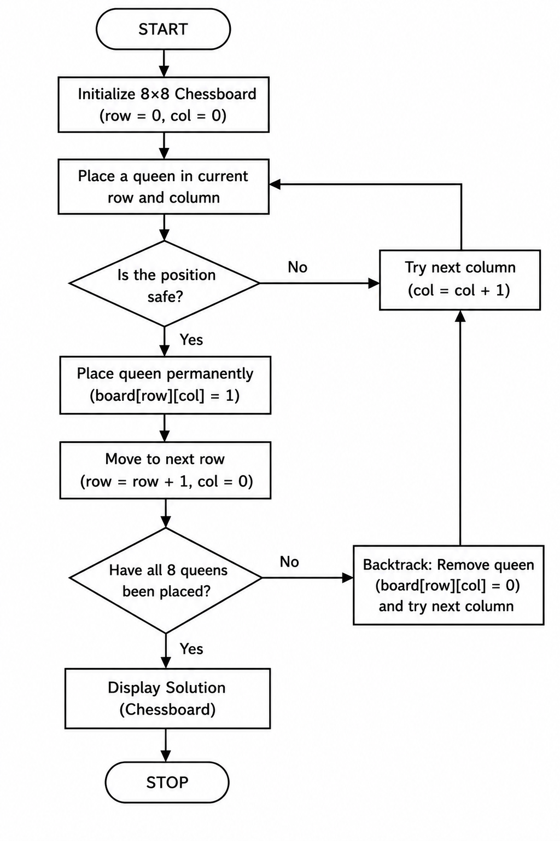
OUTPUT

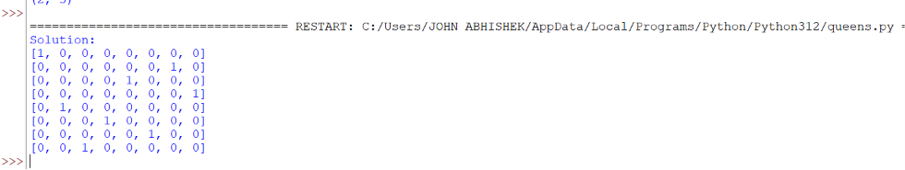

RESULT
The Python program was executed successfully. The Backtracking algorithm placed all eight queens on the chessboard without any two queens attacking each other, thereby obtaining a valid solution.

